NJ PBSIS Team

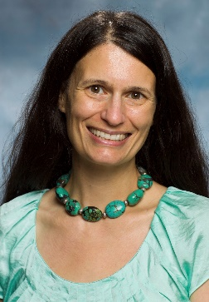 | Sharon Lohrmann, PhD  Assitant Professor of Pediatrics, Director, NJ PBSIS

Sharon Lohrmann, PhD is an Assistant Professor of Pediatrics at The Boggs Center, Rutgers Robert Wood Johnson Medical School. Dr. Lohrmann has a long-standing commitment to building capacity in NJ to implement multi-tier interventions that result in equitable access to social, emotional, and behavior wellness. Since 2004, she has directed the New Jersey Positive Behavior Support in Schools initiative (NJ PBSIS) a partnership with the New Jersey Department of Education, Office of Special Education. In the 2022-203 school year, the NJ PBSIS team delivered training and coaching support to 218 schools in 106 districts serving more than 130,000 students from 19 counties. Dr. Lohmann serves as a member of the Editorial Boards for the Journal of Positive Behavior Interventions and for Research and Practice in Severe Disabilities. She is a member of the Northeast PBIS Regional Network Advisory group www.neswpbs.org. As an NJ DOE partner she routinely participates in various NJ DOE workgroups on topics related wo social, emotional, and behavioral wellness. Dr. Lohrmann obtained her doctorate in Special Education from Lehigh University in 2004 and is the recipient of the 2009 Dr. Irwin A. Hyman Service to Children Award. Visit www.pbsisnj.org to learn more about the NJ PBSIS project.

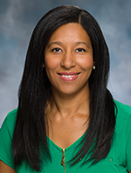 | Stephanie Michael, BA, IMH-E, MSW, LSW  Data and Program Coordinator

Stephanie Michael, MSW, LSW, is the Positive Behavior Support in Schools Data and Program Coordinator at The Boggs Center on Developmental Disabilities. Stephanie is responsible for data management, event coordination and communications. Prior to joining the Boggs Center, Stephanie provided training and technical assistance at Prevent Child Abuse – New Jersey, supporting the agency's child abuse prevention education programs, increasing community involvement in child abuse prevention and providing primary prevention for professionals, paraprofessionals, and parents. Stephanie earned her bachelor’s degree in Journalism from Baruch College, The City University of New York and her master's degree in social work from Rutgers School of Social Work. She is a licensed social worker, a certified Positive Discipline parent educator, and a Circle of Security® Parenting™ and Music Together® facilitator, respectively.
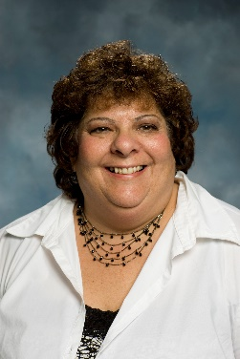 | Ann Marie McVay  Administrative Support

Ann Marie McVay is a member of the Project Support Team at The Boggs Center on Developmental Disabilities. In her role she provides support to the Positive Behavior in Schools project team funded by the New Jersey Department of Education, office of Special Education Programs. Ann Marie previously provided administrative support to the Community-Based Instruction team, coordinating trainings and acting as liaison between The Boggs Center and the Department of Education. Before joining The Boggs Center, Ann Marie worked in a support position with PSE&G for over 12 years and also held an administrative position with the North Brunswick Township Department of Parks, Recreation, and Community Services (DPRCS) handling clerical and community service assignments in addition to working with the Project Leal before and after school program. Ann Marie continues to work with the Department as a Site Supervisor for the before school program.

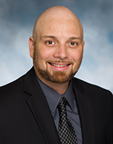 | Scott McMahon, MSW  Training and Consultation Specialists

Scott received his Master of Arts degree in Social Work from New York University. He also holds New Jersey certifications as a School Social Worker and an Elementary Teacher. He has extensive experience working within the school system. He taught a third grade class in an Abbott district, multiple grades in a gifted and talented program, as well as special education classes in inclusion settings and resource rooms. In addition to his teaching experience, Scott worked as a School Social Worker in a nationally accredited special education school focusing primarily on students with Asperger’s Syndrome. Prior to his experience in school systems, Scott worked as a Family Preservation Worker to prevent the unnecessary placement of children through intensive, in-home family counseling.

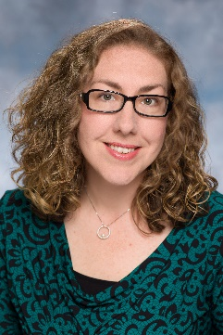 | Michelle Mead, MA  Training and Consultation Specialist

Michelle Mead, MA is a Training and Consultation Specialist for the NJ Positive Behavior Support in Schools project, a partnership between the New Jersey State Department of Education, Office of Special Education Programs, and The Boggs Center. Since 2010, Michelle has provided training and technical assistance on positive behavior supports and interventions. Prior to joining The Boggs Center, Michelle held a range of positions in education. She used her dual-certification in Elementary Education and Special Education to teach in an inclusion classroom as a Third Grade Teacher; provide Early Intervention services as a Developmental Interventionist; and to provide family training and classroom support as a Home-School Liaison for a school serving students with Autism Spectrum Disorder. Michelle earned her Bachelor of Arts Degree in Elementary Education and Psychology, with an endorsement in Special Education from Saint Elizabeth University (SEU). She returned to SEU for her graduate studies. Michelle graduated in 2010 with her Masters Degree in Counseling Psychology. Her research and implementation interests continue to include mental health interventions, racial equity in schools, and social and emotional learning.

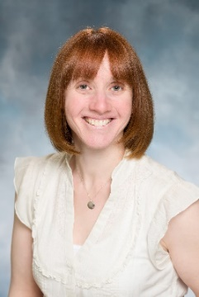 | Karen Paulvin, MS Prof. Dipl.  Training and Consultation Specialists

Karen Paulvin is a Training and Consultation Specialist at The Boggs Center on Developmental Disabilities. She provides training and technical assistance to schools involved in the NJ Positive Behavior Supports in Schools project, a partnership between the New Jersey State Department of Education, Office of Special Education Programs, and The Boggs Center. Karen earned her undergraduate degree from Rutgers University with a major in psychology. She went on to earn a Master of Science in Clinical Psychology from Loyola College in Baltimore, MD and a Professional Diploma in School Psychology from Kean University, Union, NJ. She is also certified as a school psychologist in New Jersey. Prior to working at The Boggs Center, Karen worked as a school psychologist in the public school setting with various grade levels and populations including students with behavioral disabilities and autism. As a school psychologist, she functioned as a child study team member and case manager, conducted psychological evaluations and functional behavioral assessments, and developed behavioral intervention plans. In addition, Karen provided school-based services including consultation with teachers and staff, counseling to students, and crisis intervention for students. She also provided parent training to parents of children with autism. Karen also worked for more than ten years as a consultant/tutor for Douglass Developmental Disabilities Center (DDDC) providing home-based services to children with autism.

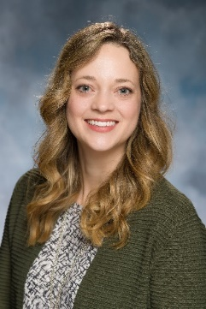 | Beth Custer, PhD  Training and Consultation Specialist

Beth Custer is a Training and Consultation Specialist at The Boggs Center on Developmental Disabilities. She promotes the use of positive behavioral supports through training and technical assistance with schools involved in the NJ Positive Behavior Supports in Schools project, which is a partnership between the New Jersey State Department of Education, Office of Special Education Programs, and The Boggs Center, Rutgers University. Prior to her position at The Boggs Center, she earned a dual Bachelor of Science in elementary education and special education in 2004 from Bloomsburg University of Pennsylvania. Upon completion, she immediately began working as a full-time emotional support teacher at a residential treatment facility for students who require more intensive supports due to significant mental health needs. In 2009, she completed her Master of Education in special education from Alvernia University and obtained a position as a district-level, special education behavior support coach for Exeter Township School District in Reading, Pennsylvania. While at Exeter, she worked with teachers, administrators, families and other staff to support special education students who exhibited challenging behaviors during the school day. In 2012, she joined Lehigh University in Bethlehem, Pennsylvania and enrolled in the doctoral program in special education until completing the requirements to earn her PhD in 2018. During this time, she pursued her passion of supporting students with emotional and behavioral disorders through the use of positive, proactive interventions. Following her time at Lehigh, she worked in the specialized education services department at the University of North Carolina at Greensboro (UNCG) as a Grant Coordinator. This position required her to support activities on the Center for Technical Assistance, Instruction, Education and Support (TIES), which is a national research center through the University of Minnesota.

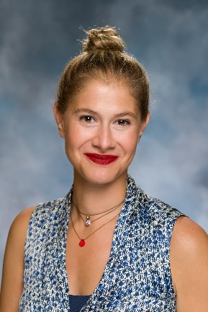 | Gizem Tanol, PhD  Training and Consultation Specialist

Gizem Tanol, PhD is a Training and Consultation Specialist at The Boggs Center. She provides training and technical assistance to schools involved in the NJ Positive Behavior Support in Schools project, a partnership between the New Jersey State Department of Education, Office of Special Education Programs, and The Boggs Center. Dr. Tanol has served as the Director of Program Quality and Evaluation at NYU Steinhardt’s ASD Nest Support Project. She has extensive clinical experience in pre- and in-service teacher training on autism spectrum disorders (ASD), understanding challenging behavior, parent training, and implementing positive behavior support framework in inclusive and community settings. For several years, Dr. Tanol served as an Adjunct Assistant Professor of Early Childhood Special Education at Hunter College, teaching such courses on behavior theory and student teaching/practicum seminars. Dr. Tanol’s research interests include implementation of class-wide reinforcement systems in inclusive settings and the fidelity of implementation of evidence-based classroom practices. Dr. Tanol has been recognized as a Rising Alumni by the University of Minnesota, CEHD Alumni Society for achieving early distinction in her career, demonstrating outstanding leadership, and showing exceptional volunteer service in the community. In 2011, she completed her PhD program at the University of Minnesota, Educational Psychology program with a specialization in Special Education. She holds a BA in Psychology from Koc University (Istanbul, Turkey) and a Masters in Educational Psychology from University of Minnesota

