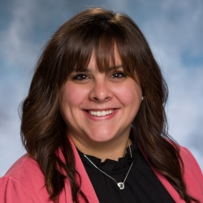 | Alyson Duncanson, BA  Training and Consultation Specialist

Alyson Duncanson, BA is a Training and Consultation Specialist providing training and technical assistance to schools involved in the NJ Positive Behavior Support in Schools project, a partnership between the New Jersey Department of Education, Office of Special Education, and The Boggs Center. Prior to joining the NJPBSIS team, Alyson spent 12 years in public education as a Special and General Education Literacy teacher and district technology trainer. She has experience across various educational settings and has provided instructional and intervention services for students with a wide range of abilities in grades Pre-K through 6th. Alyson earned her Bachelor of Arts degree and Elementary Education certification from Muhlenberg College and continued her studies in Special Education at Kean University, where she received her Teacher of Students with Disabilities endorsement. Her research and implementation interests include developmental psychology, social-emotional learning, social equity, and adaptive and assistive technology

