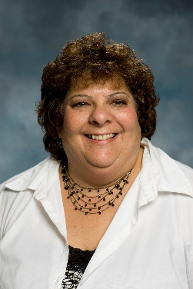 | Ann Marie McVay  Administrative Support

Ann Marie McVay is a member of the Project Support Team at The Boggs Center on Developmental Disabilities. In her role she provides support to the Positive Behavior in Schools project team funded by the New Jersey Department of Education, office of Special Education Programs. Ann Marie previously provided administrative support to the Community-Based Instruction team, coordinating trainings and acting as liaison between The Boggs Center and the Department of Education. Before joining The Boggs Center, Ann Marie worked in a support position with PSE&G for over 12 years and also held an administrative position with the North Brunswick Township Department of Parks, Recreation, and Community Services (DPRCS) handling clerical and community service assignments in addition to working with the Project Leal before and after school program. Ann Marie continues to work with the Department as a Site Supervisor for the before school program.

