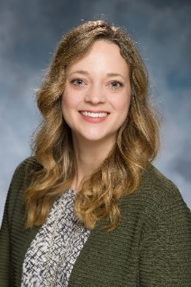 | Beth Custer, PhD  Training and Consultation Specialist

Beth Custer is a Training and Consultation Specialist at The Boggs Center on Developmental Disabilities. She promotes the use of positive behavioral supports through training and technical assistance with schools involved in the NJ Positive Behavior Supports in Schools project, which is a partnership between the New Jersey State Department of Education, Office of Special Education Programs, and The Boggs Center, Rutgers University. Prior to her position at The Boggs Center, she earned a dual Bachelor of Science in elementary education and special education in 2004 from Bloomsburg University of Pennsylvania. Upon completion, she immediately began working as a full-time emotional support teacher at a residential treatment facility for students who require more intensive supports due to significant mental health needs. In 2009, she completed her Master of Education in special education from Alvernia University and obtained a position as a district-level, special education behavior support coach for Exeter Township School District in Reading, Pennsylvania. While at Exeter, she worked with teachers, administrators, families and other staff to support special education students who exhibited challenging behaviors during the school day. In 2012, she joined Lehigh University in Bethlehem, Pennsylvania and enrolled in the doctoral program in special education until completing the requirements to earn her PhD in 2018. During this time, she pursued her passion of supporting students with emotional and behavioral disorders through the use of positive, proactive interventions. Following her time at Lehigh, she worked in the specialized education services department at the University of North Carolina at Greensboro (UNCG) as a Grant Coordinator. This position required her to support activities on the Center for Technical Assistance, Instruction, Education and Support (TIES), which is a national research center through the University of Minnesota.

