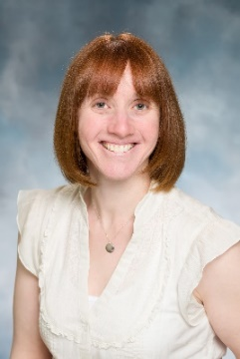 | Karen Paulvin, MS Prof. Dipl.  Training and Consultation Specialists

Karen Paulvin is a Training and Consultation Specialist at The Boggs Center on Developmental Disabilities. She provides training and technical assistance to schools involved in the NJ Positive Behavior Supports in Schools project, a partnership between the New Jersey State Department of Education, Office of Special Education Programs, and The Boggs Center. Karen earned her undergraduate degree from Rutgers University with a major in psychology. She went on to earn a Master of Science in Clinical Psychology from Loyola College in Baltimore, MD and a Professional Diploma in School Psychology from Kean University, Union, NJ. She is also certified as a school psychologist in New Jersey. Prior to working at The Boggs Center, Karen worked as a school psychologist in the public school setting with various grade levels and populations including students with behavioral disabilities and autism. As a school psychologist, she functioned as a child study team member and case manager, conducted psychological evaluations and functional behavioral assessments, and developed behavioral intervention plans. In addition, Karen provided school-based services including consultation with teachers and staff, counseling to students, and crisis intervention for students. She also provided parent training to parents of children with autism. Karen also worked for more than ten years as a consultant/tutor for Douglass Developmental Disabilities Center (DDDC) providing home-based services to children with autism.

