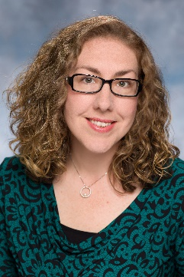 | Michelle Mead, MA  Training and Consultation Specialist

Michelle Mead, MA is a Training and Consultation Specialist for the NJ Positive Behavior Support in Schools project, a partnership between the New Jersey State Department of Education, Office of Special Education Programs, and The Boggs Center. Since 2010, Michelle has provided training and technical assistance on positive behavior supports and interventions. Prior to joining The Boggs Center, Michelle held a range of positions in education. She used her dual-certification in Elementary Education and Special Education to teach in an inclusion classroom as a Third Grade Teacher; provide Early Intervention services as a Developmental Interventionist; and to provide family training and classroom support as a Home-School Liaison for a school serving students with Autism Spectrum Disorder. Michelle earned her Bachelor of Arts Degree in Elementary Education and Psychology, with an endorsement in Special Education from Saint Elizabeth University (SEU). She returned to SEU for her graduate studies. Michelle graduated in 2010 with her Master’s Degree in Counseling Psychology. Her research and implementation interests continue to include mental health interventions, racial equity in schools, and social and emotional learning.

