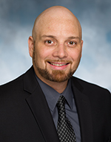 | Scott McMahon, MSW  Training and Consultation Specialists

Scott received his Master of Arts degree in Social Work from New York University. He also holds New Jersey certifications as a School Social Worker and an Elementary Teacher. He has extensive experience working within the school system. He taught a third grade class in an Abbott district, multiple grades in a gifted and talented program, as well as special education classes in inclusion settings and resource rooms. In addition to his teaching experience, Scott worked as a School Social Worker in a nationally accredited special education school focusing primarily on students with Asperger’s Syndrome. Prior to his experience in school systems, Scott worked as a Family Preservation Worker to prevent the unnecessary placement of children through intensive, in-home family counseling.

